Week 1 Homework | 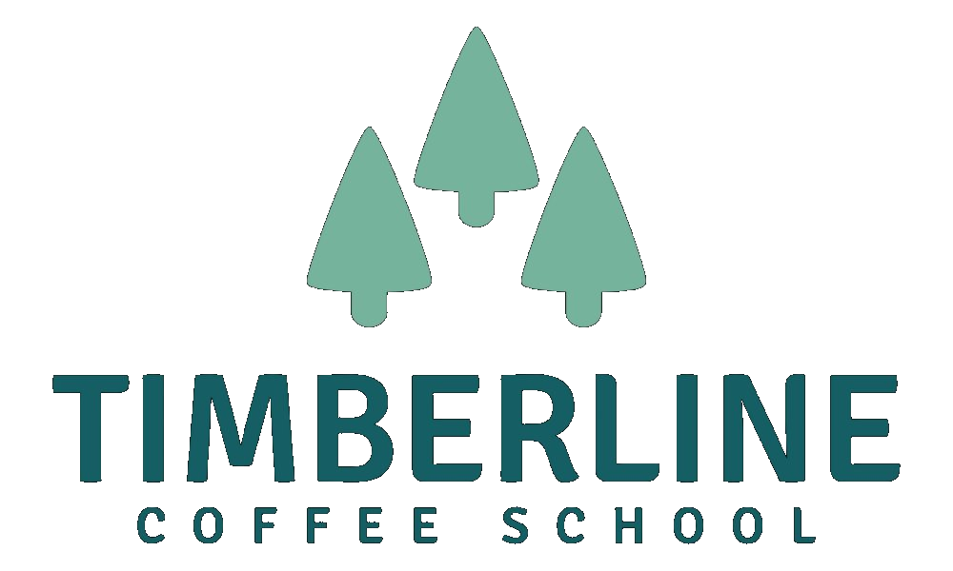

Competitor Visit Notes
Before the live call, visit two coffee shops in your area — places your target customer might go instead of your shop. Go as a customer, not a business owner. Sit down, order something, and notice how you feel. Use this sheet to capture your observations for each visit.
Shop 1 First Competitor Visit

Shop name:
What does this shop do really well?
What kind of customer does it seem built for?
What does it not do well, or what does it leave on the table?
Is there a gap — something a customer might want that this shop isn’t giving them?

Shop 2 Second Competitor Visit

Shop name:
What does this shop do really well?
What kind of customer does it seem built for?
What does it not do well, or what does it leave on the table?
Is there a gap — something a customer might want that this shop isn’t giving them?

→ What did you take away?
Looking across both visits — what did you notice about the gap your shop could fill? Bring this to the live call.

Timberline Coffee School — Opening Your Coffee Shop Cohort — Week 1

